Group’s Members:
Huynh Tan Dung
Bui Nguyen Truc Nhu
Phan Hai Huy
Tran Dinh Duy
Manga reader APPLICATION PROJECT
-Group 1 -

- Scope of Project
The purpose of this software development project is to create a new application called: Manga Reader where everyone can log in and read manga stories. The client for this project wishes to enter web and app environment.
The Manga Reader is implemented on the android platform, allowing users to search for the hottest manga stories. Besides that, we have a Web Admin Server to manage the manga stories inventory and user database.
- The application will provide the following capabilities:
• The availability of information at any time in any place via internet access.
• Admin will be able, to manage the manga stories inventory database including remove change, and add.
• User in system will be able to manage account: Create, View, Change Info of their account.
• User will able to read, vote, follow Manga Story.
• System will be able to auto update top Manga Stories reading.
• The application will provide search function on books based on genres, title.

II. Product.
- Who are the users?
  - User Group:
- Application Manager (Admin)
- Manga Reader (User).

The following table describe general user characteristics that will affect the functionality of the software product.
Type of User | User Characteristic | User Technical Expertise | How the user characteristic and technical expertise affect DLSSYSTEM functionality
Application Manager | Good understanding to library operation Responsible for library operation as a whole. | Know how to use PC, and can acc internet. | User interface with less input steps.  Easy to learn.
User | Find stories in their specification and read material.  Will not have any formal training to use the system. | Have Smartphone and know how to download app. | GUI interface may be easier to learn than text interface. Provide system help.  Provide appropriate error messages for invalid user inputs.

  - User preferences (if identified)
- GUI convenient, beauty (if can).
  - User level of education:
- All educational levels but we primarily focus on users aged 15+.
  - User level of technical knowledge
- Average in technical proficiency.
- Manager: know how to use PC, and can acc internet.
- Users: have Smartphone and know how to download app.
  - User level of experience with technology/ similar products:
- No much important.
  - Nature of user engagement with the product:
- Manager: Manage all manga stories inventory and help user.
- Users: login, select the manga story that they want and enjoy.
- Where will your product be used?
  - Environments where the product is meant to be used:
In everywhere.
  - Environmental constraints on the use of this product:
    - This system is Web based for Manager, there will be a need to provide PC Server hardware connected to the internet.
    - This system is App on Phone for Users, there will be need smartphone.
    - This App must be designed for easy to use, providing help instructions, and appropriate error messages for invalid user inputs.
    - Security is important to library operation. Manga Reader/Users are allowed to use the system only for searching story records. Users should never be able to break into the system and to perform any modification.
    - Reliability is vital to library operation.
- For what purpose will it be used?
  - Purpose:
Users who want to relax after school, work, have a hobby of reading comics, want to read stories for free.
  - Functional Needs:
    - Manager/Admin: Create, Update, Remove the comic, manage the manga stories inventory and user database.
    - Users: Register, Login, Search, Vote.
  - Nonfunctional Needs:
    - Easy to use, easy to interact with the application.
    - The interface is pretty, good-looking.
    - The desired response speed when users interact with the application: 5s.
- Structure:
  - Server for Android App:
- Java Spring Boot, JPA Data
    - Base on 3-layer structure:
      - Presentation Layer (Controller)
      - Business Logic Layer (Service)
      - Data Access Layer (Repository)
    - Structure of project:
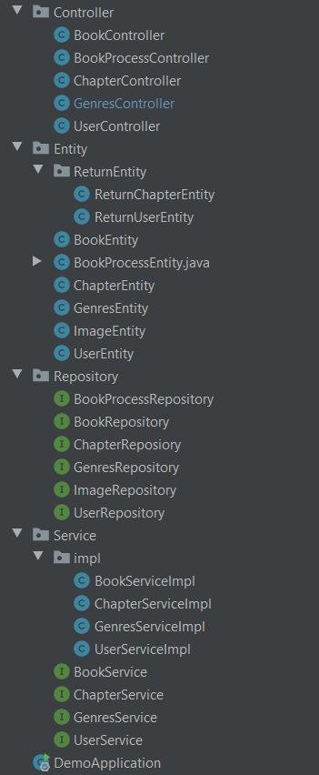

      - Controller:
    - The communication layer with the end user (client) to display data, collect data, check the correctness of the data before calling the service layer.
    - Here are the api link call from user. Example:
      - https://mangapandaapi.herokuapp.com/manga/title/ta
    - In rest, the HttpMethod as get, post, put, delete, ... with the goal of taking data, adding data, updating data, deleting, …
    - Class:
      - BookController
      - BookProcessController
      - ChapterController
      - GenresController
      - UserController
    - Example:
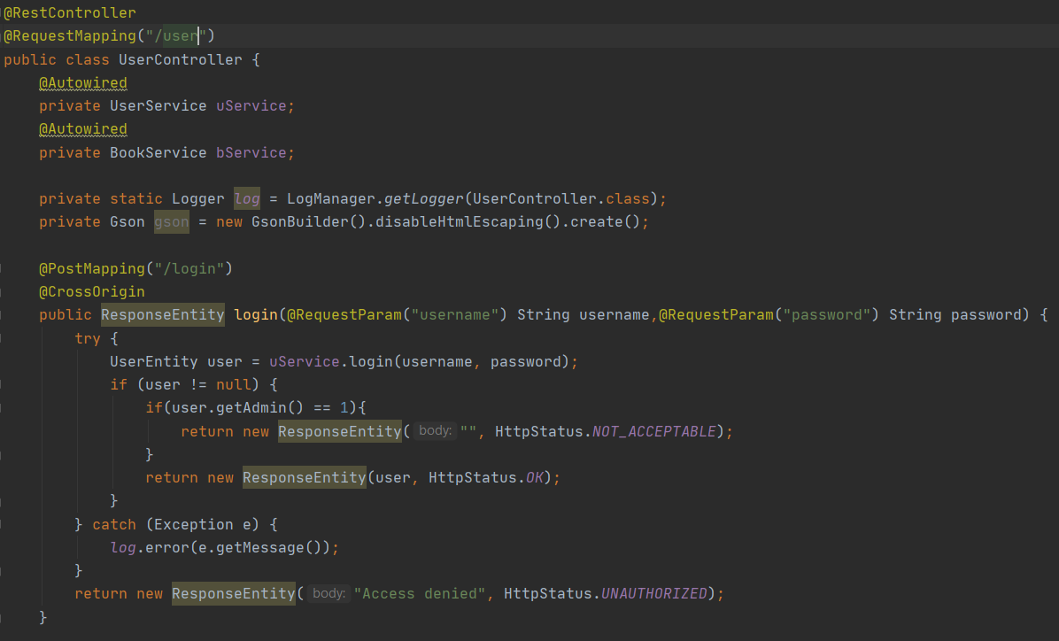
      - Service:
    - This is a place to check data constraints, integrity and validity. This is also the place for calculating and processing according to the operations and logic of the request.
    - This is the place where business logic is handled.
    - Depedency Injection so in our project Service package we divide into 2 part Interface and Implement
    - Class Interface:
      - BookService
      - ChapterService
      - GenreService
      - UserService
    - Class Implement
      - BookServiceImpl
      - ChapterServiceImpl
      - GenreServiceImpl
      - UserServiceImpl
    - Example:
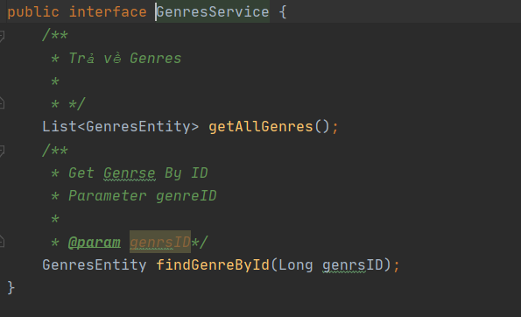
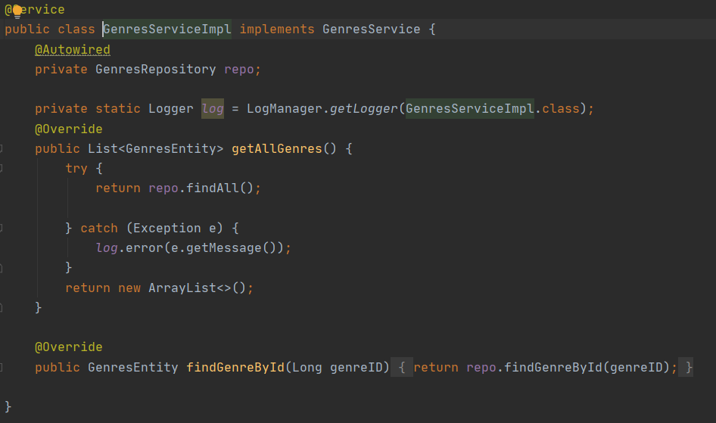
      - Repository:
    - This is the place to communicate with the database, process queries and return the desired service data.
    - This class to manipulate data. Here I use the jpa library, so everything else I add, delete… on the service side is in the JpaRepository.( extends JpaRepository).
    - Class:
      - BookRepository
      - BookProcessRepository
      - ChapterReposiory
      - GenresRepository
      - ImageRepository
      - UserRepository
    - Example:

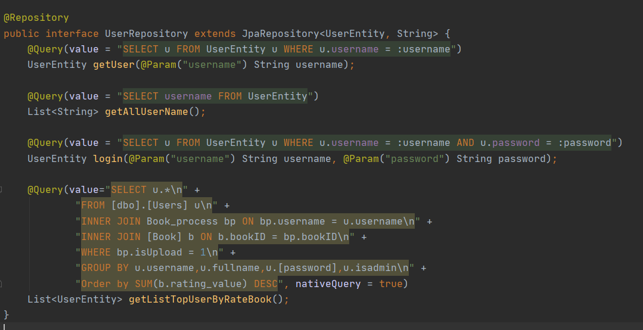

      - Entity:
    - Entity is for mapping from a database (DTO) and used for format data send to end user(client)
    - Class:
      - BookEntity: map table Book in database.
      - BookProcessEntity: map table Book_process in database.
      - ChapterEntity: map table Chapter in database.
      - GenresEntity: map table Genre in database.
      - ImageEntity: map table Chapter_image in database.
      - UserEntity: map table Users in database.
      - Return Entity: used for format data send to end user(client)
        - ReturnChapterEntity
        - ReturnUserEntity
      - Example:
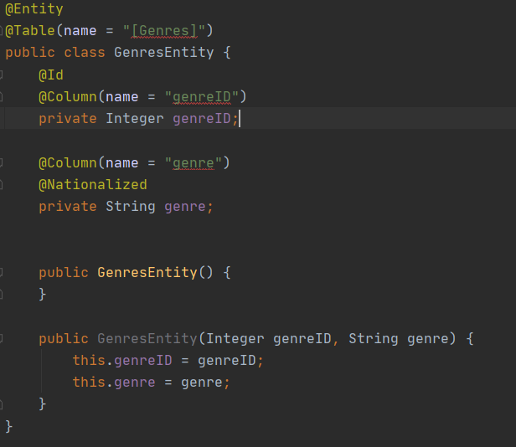

- Usercase:
